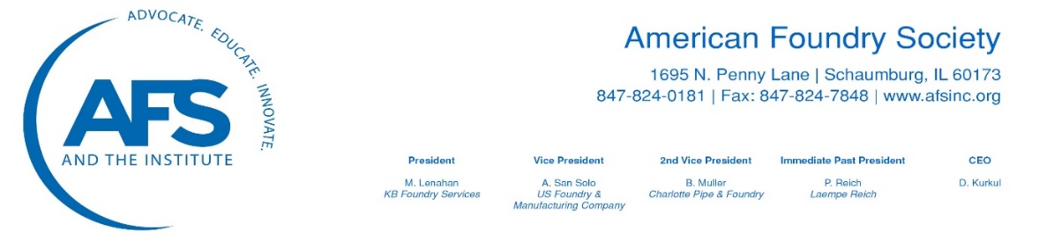
February 11, 2021
The Honorable Secretary Pete Buttigieg
U.S. Department of Transportation
1200 New Jersey Avenue, S.E.
Washington, D.C. 20590
Dear Secretary Buttigieg:
On behalf of the American Foundry Society (AFS) and our 7,000 manufacturing and supplier members, congratulations on your confirmation as the U.S. Secretary of Transportation. We look forward to working with you and your team as you implement President’s Biden’s ‘Build Back Better’ plan and help lay the groundwork for sustained, strong economic growth that benefits all Americans.
It is time to modernize our nation’s transportation and water infrastructure. Making a long-term infrastructure investment now will not only respond to our country’s urgent infrastructure needs but will provide a major boost to the economy and job creation.

AFS is the major technical and trade association for the $44 billion metalcasting industry. Metalcasters will play an essential role in modernizing U.S. infrastructure. AFS members manufacture pipes, pumps, flow meters, fire hydrants, wheel frames, gear castings, engine blocks, engines, exhaust manifolds, rail-car axles, rail suspension and coupling systems, rail brakes, aerospace components and hundreds of related products. Highly engineered castings are crucial to national defense and a wide range of essential industries. In fact, castings are part of 90 percent of durable goods and more than 40 percent of all castings are related to infrastructure.

On the national level, the metalcasting industry is responsible for more than $110 billion in economic output and 490,000 jobs (direct and indirect) that pay more than $32.1 billion in wages and benefits. In your home state, more than 75 metalcasting facilities manufacture thousands of ferrous and nonferrous castings, making Indiana the eighth largest metalcasting state in the nation, and providing more than 35,000 jobs (direct and indirect), generating $2.4 billion in wages, and contributing $8.68 billion to the state economy.
Our nation should take advantage of this historic, bipartisan opportunity to transform our transportation systems – with American workers and materials – by implementing the following four job-creating policies:

- Modernizing our nation’s infrastructure, including roads, highways, bridges, airports, railroad and transit, schools, and ports, as well as drinking water and wastewater systems. As you know, these critical assets are in urgent need of repair, maintenance, and sustainable investment.
- Strengthening and expanding Buy-America rules for projects that draw upon U.S. tax dollars. Policies should ensure that federal highway, transit, and rail funds purchase American-made metal products under the Buy-America rules. Increasing federal purchases of U.S. castings and manufactured goods for all DOT-funded projects will reinvest tax dollars back into the local and national economy.
- Incentivizing private investment in the freight railcar manufacturing industry by providing a tax credit for U.S. railcar leasing and manufacturing companies for the cost of replacing two existing railcars with a new fuel-efficient railcar or for refurbishing an existing railcar, which will support good-paying jobs and protect America’s supply chain.
- Streamlining and accelerating the federal permitting process. Our nation’s lengthy permitting and environmental review process can add to projects’ time and cost, while deterring the entry of private capital.
We look forward to hosting you at one or more of our member-company facilities when the pandemic subsides to see first-hand the production of thousands of innovative, highly engineered metal castings by our outstanding workforce.
Thank you again for your commitment to public service. The U.S. metalcasting industry stands ready to work with you to grow the economy, enhance Buy America rules and purchases, and modernize our transportation and water infrastructure. If you would like additional information regarding our critical industry, please contact me or our AFS Washington representative, Stephanie Salmon, ssalmon@afsinc.org.
Sincerely,
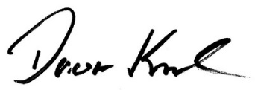
Doug Kurkul
CEO

