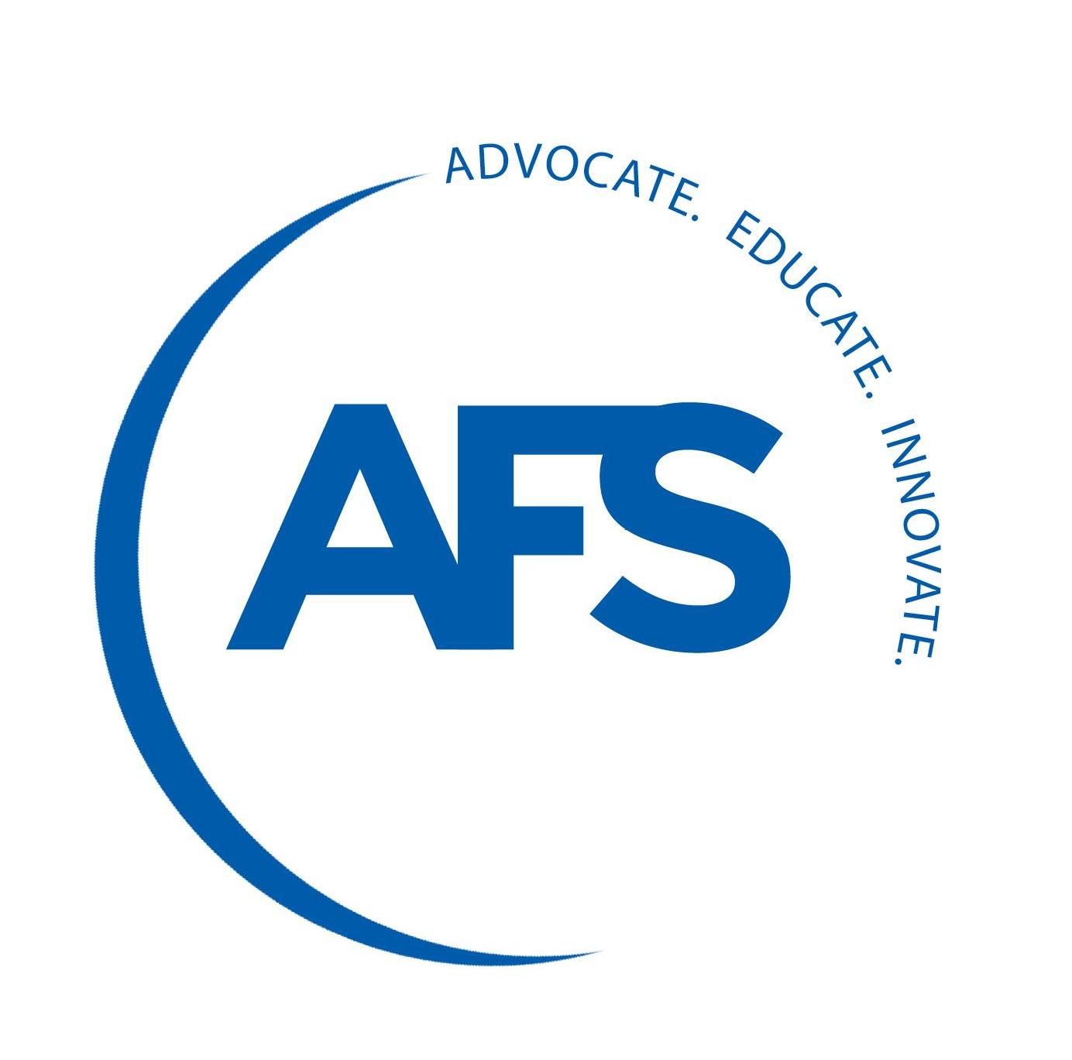

2022 AFS Safe Year Award Application

Award Criteria
The AFS Safe Year Award recognizes AFS Corporate Member facilities, at a single location, which have achieved one year (365 consecutive calendar days) without a lost-time incident or death. Because the Environmental, Health & Safety (EHS) Conference has been moved from August to October of each year, the due date for Safe Year Award applications has been pushed back to June 1 of each year. The one-year count begins the day after your last lost-time incident. When 365 consecutive calendar days have passed without a lost-time incident or death, the company may submit a verified application. Applications must be only for a 365-day period. (For example, if the last lost time incident occurred on May 10th, 2019 the award application would be for May 11th, 2019 through May 10th, 2020.)

Only AFS Corporate Members are eligible to enter. Application deadline is Monday, June 13th, 2022. The awards will be presented at the AFS Environmental Health & Safety Conference the following October. If you have any questions, please call (800) 537-4237, ext. 246 or email kperna@afsinc.org

Application Details — (Please type or print)

Organization Name (As it will appear on the plaque):

Award Facility Location: NAICS/SIC:

Process/Product(s) Made: Number of Employees:

Company Contact: Title:

Address:

City: State: Zip:

Phone: E-mail:

Period for which this award is being applied: From: _______________ To: __ _____________ __2021

Person who will receive the award at the Conference: _______________________________________
(We will mail awards to you if no one can attend the conference.)

Application Verification — (Signed and dated by company officer)

I certify that the above information is correct, and our foundry is an AFS Corporate Member:

Print name: Signature:

Title: Date:

E-mail completed application to
Kimberly Perna: kperna@afsinc.org
Deadline: Monday, June 13,2022

